**Commodore VIC-20 Character ROM Adapter Rev. 0**

Module Description

The character ROM 901450-03 of the Commodore VIC-20 is a 2332 type ROM. Other than in the C64, it makes use of the 2nd chip select for address decoding. Thus, the C64 character ROM adapter (project number 126) is not suitable for the VIC-20.

The VIC-20 Character ROM adapter fixes this. Also, the geometry is different from the C64 Character ROM adapter to make it fit into ASSY250403, where it is pretty close to the RF-shield of the video circuit.

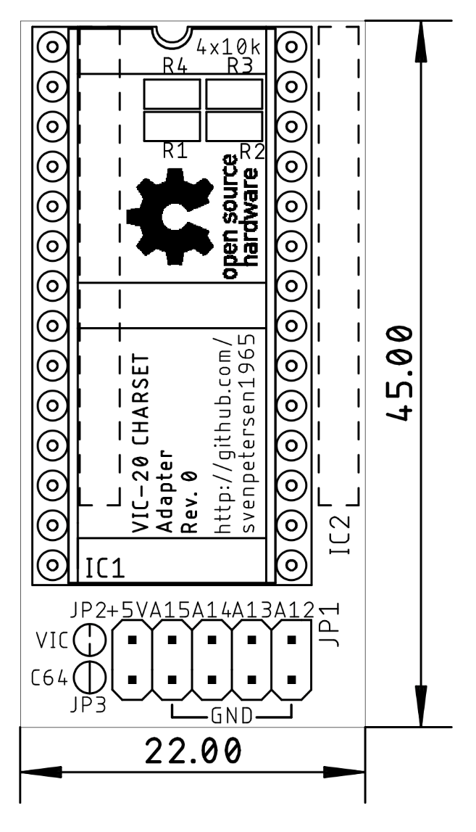

Figure 1: Dimensions

The VIC-20 Character ROM adapter can be configured to work with the C64 with solder bridges (JP2 & JP3). The default configuration is the VIC-20 mode, though. For the C64 short board, it fits mechanically quite well, due to the alignment of the socket/PCB to the left side or the ROM socket on the C64.

|  |  |  |
| --- | --- | --- |
| Computer | JP2 | JP3 |
| VIC-20 | closed | open |
| C62 | open | closed |

Table 1: Compatibility configuration

This pin-header JP1 is connected in a way, that the selection can either be accomplished with standard 2.54mm jumper bridges, DIP-switches, hex-encoding switches or a microcontroller like an Arduino etc.

|  |  |  |  |
| --- | --- | --- | --- |
| **Signal** | **Pin** | **Pin** | **Signal** |
| A12 | 1 | 2 | GND |
| A13 | 3 | 4 | GND |
| A14 | 5 | 6 | GND |
| A15 | 7 | 8 | GND |
| +5V | 9 | 10 | n.c. |

Table 2: Jumper (JP1) for Bank Selection

The +5V pin is suitable to provide supply voltage to a microcontroller.

# Bank Selection

The desired CHARACTER SET is selected at JP1. For the pinout refer to Table 2. The jumper is installed (vertically) in a way, that it connects the address line with the GND potential.

| A15 | A14 | A13 | A12 | 4k Block | | Addr. Offset |
| --- | --- | --- | --- | --- | --- | --- |
| set | set | set | set | | #0 | 0x0000 |
| set | set | set | open | | #1 | 0x1000 |
| set | set | open | set | | #2 | 0x2000 |
| set | set | open | open | | #3 | 0x3000 |
| set | open | set | set | | #4 | 0x4000 |
| set | open | set | open | | #5 | 0x5000 |
| set | open | open | set | | #6 | 0x6000 |
| set | open | open | open | | #7 | 0x7000 |
| open | set | set | set | | #8 | 0x8000 |
| open | set | set | open | | #9 | 0x9000 |
| open | set | open | set | | #10 | 0xA000 |
| open | set | open | open | | #11 | 0xB000 |
| open | open | set | set | | #12 | 0xC000 |
| open | open | set | open | | #13 | 0xD000 |
| open | open | open | set | | #14 | 0xE000 |
| open | open | open | open | | #15 | 0xF000 |

Table 3: Selection of EPROM memory blocks (@JP1)

A set jumper corresponds to a LOW level (binary 0), an open jumper to a HIGH level. Do not confuse the C64 memory address and the EPROM memory address. They have the address Bit A0 to A11 in common, but the rest is different. Each of the 4k blocks appears between address $D000 and $DFFF of the C64.

# Compatibility of EPROMs

Although a 27C512 type EPROM is recommended, other types of EPROMs can be installed:

|  |  |  |
| --- | --- | --- |
| EPROM | Size | Capacity |
| 27C64 | 8k | 2x Character Sets |
| 27C128 | 16k | 4x Character Sets |
| 27C256 | 32k | 8x Character Sets |
| 27C512 | 64k | 16x Character Sets |

Table 4: Capacity of EPROM types

Those EPROMs are pin compatible, the jumpers, that have no function, due to the size, have to stay open.

|  |  |  |  |  |  |
| --- | --- | --- | --- | --- | --- |
| EPROM | Size | A15 | A14 | A13 | A12 |
| 27C512 | 64kx8 | 🗹 | 🗹 | 🗹 | 🗹 |
| 27C256 | 32kx8 | open | 🗹 | 🗹 | 🗹 |
| 27C128 | 16kx8 | open | open | 🗹 | 🗹 |
| 27C64 | 8kx8 | open | open | open | 🗹 |

Table 5: Settings per EPROM type

🗹: The jumper can be open or closed, depending on the desired selection.

In case Vpp is located at a dedicated pin (pin 1), A15 has no effect anymore. A HIGH level is recommended, the corresponding jumper is open. The /PGM Pin should be set HIGH, this is accomplished by an open jumper for A14.

|  |  |  |  |  |  |  |  |  |  |  |  |
| --- | --- | --- | --- | --- | --- | --- | --- | --- | --- | --- | --- |
| 27C64 | | | | | | | | | | | |
|  | 27C128 | | | | | | | | | |  |
|  | 27C256 | | | | | | | |  |
|  | 27C512 | | | | | |  |
|  | SOCKET | | | |  |
| Vpp | Vpp | Vpp | A15 | 1 | A15 | VCC | 28 | VCC | VCC | VCC | VCC |
| A12 | A12 | A12 | A12 | 2 | A12 | A14 | 27 | A14 | A14 | /PGM | /PGM |
| A7 | A7 | A7 | A7 | 3 | A7 | A13 | 26 | A13 | A13 | A13 | n.c. |
| A6 | A6 | A6 | A6 | 4 | A6 | A8 | 25 | A8 | A8 | A8 | A8 |
| A5 | A5 | A5 | A5 | 5 | A5 | A9 | 24 | A9 | A9 | A9 | A9 |
| A4 | A4 | A4 | A4 | 6 | A4 | A11 | 23 | A11 | A11 | A11 | A11 |
| A3 | A3 | A3 | A3 | 7 | A3 | /OE | 22 | /G/Vpp | /G | /G | /G |
| A2 | A2 | A2 | A2 | 8 | A2 | A10 | 21 | A10 | A10 | A10 | A10 |
| A1 | A1 | A1 | A1 | 9 | A1 | GND | 20 | /E | /E | /E | /E |
| A0 | A0 | A0 | A0 | 10 | A0 | D7 | 19 | D7 | D7 | D7 | D7 |
| D0 | D0 | D0 | D0 | 11 | D0 | D6 | 18 | D6 | D6 | D6 | D6 |
| D1 | D1 | D1 | D1 | 12 | D1 | D5 | 17 | D5 | D5 | D5 | D5 |
| D2 | D2 | D2 | D2 | 13 | D2 | D4 | 16 | D4 | D4 | D4 | D4 |
| GND | GND | GND | GND | 14 | GND | D3 | 15 | D3 | D3 | D3 | D3 |

Table 6: EPROM pin compatibility

# Using parallel EEPROMs

There are ***parallel*** EPROMs, which fit into the EPROM sockets. They do not require erasing with a UV eraser, like EPROMs, but the price is higher.

Since they can be written, which is controlled by the signal, but the Super Expander II cartridge is lacking of this functionality, this signal has to be HIGH (inactive). The 28C256 has the A14 signal connected to Pin 1, which is A15 of the EEPROM socket. This is no problem, but it has to be kept in mind, that the jumper for A15 has effect on the bank select A14 of the EPROM.

|  |  |  |  |  |  |  |  |
| --- | --- | --- | --- | --- | --- | --- | --- |
| 28C64 | | | | | | | |
|  | 28C256 | | | | | |  |
|  | SOCKET | | | |  |
| n.c. | 💣A14 | 1 | A15 | VCC | 28 | VCC | VCC |
| A12 | A12 | 2 | A12 | A14 | 27 | /WE | /WE |
| A7 | A7 | 3 | A7 | A13 | 26 | A13 | n.c |
| A6 | A6 | 4 | A6 | A8 | 25 | A8 | A8 |
| A5 | A5 | 5 | A5 | A9 | 24 | A9 | A9 |
| A4 | A4 | 6 | A4 | A11 | 23 | A11 | A11 |
| A3 | A3 | 7 | A3 | /OE | 22 | /G/Vpp | /OE |
| A2 | A2 | 8 | A2 | A10 | 21 | A10 | A10 |
| A1 | A1 | 9 | A1 | GND | 20 | /E | /CE |
| A0 | A0 | 10 | A0 | D7 | 19 | D7 | D7 |
| D0 | D0 | 11 | D0 | D6 | 18 | D6 | D6 |
| D1 | D1 | 12 | D1 | D5 | 17 | D5 | D5 |
| D2 | D2 | 13 | D2 | D4 | 16 | D4 | D4 |
| GND | GND | 14 | GND | D3 | 15 | D3 | D3 |

Table 7: EEPROM pin compatibility

|  |  |  |  |  |
| --- | --- | --- | --- | --- |
| EEPROM | Size | A15 | A14 | A13 |
| 28C256 | 32kx8 | =A14 | OPEN | yes |
| 28C64 | 8kx8 | OPEN | OPEN | OPEN |

Table 8: Settings per EEPROM type

# Programming instructions

Character sets can be found here:

<http://www.zimmers.net/anonftp/pub/cbm/firmware/computers/vic20/index.html> or elsewhere. For instructions on setting up a complete multiple character ROM image, please refer to

<https://github.com/svenpetersen1965/C64-Kernal-Adapter-Switch-Long-Board/blob/master/Rev.%200/pdf/C64_KernalSw_8k_v0.pdf>

The description is about how to create a multiple Kernal ROM image, a multiple Character ROM image works pretty similar, except the size is only 4kB.

# Revision History

## Rev. 0

* Fully working Prototype.